
Woodchop and Chainsaw Racing Competitions Arena Layout Considerations

Layout Considerations
- Competition Area:
-Chopping blocks/stands should be positioned centrally within the competition area.
-Each competitor requires adequate space to swing their axes safely without interfering with others.
- Safety Barriers:
-Barriers should enclose the entire competition area to ensure only authorised personnel can enter.
-A secondary barrier should separate spectators from competitors, providing a safe distance to protect against flying debris.
- Entry and Exit Points:
-Clearly marked entry and exit points are required for competitors, officials, and emergency services.
Protection Barriers
- Types of Barriers:
-Fencing: Use sturdy, non-climbable fencing at least 1.2 metres high.
-Netting: High-tensile netting can catch flying debris and offer additional protection.
-Solid Barriers: Plywood or other solid materials can shield areas directly behind competitors.
- Placement:
-Perimeter fencing should surround the entire competition area.
-Internal barriers should be placed between each chopping stand to prevent interference.
-A buffer zone of at least 2–3 metres should be maintained between the competition area and spectators, with barriers protecting against flying debris.

- Material:
-Barriers should be made from durable materials capable of withstanding impact from wood chips and axe heads.
-Barriers should not obstruct the spectators’ view unnecessarily, unless safety requires it.

Safety Zones
- Competitor Safety Zone: An area behind each chopping block where competitors can safely retreat.
- Officials Zone: A designated area for judges and officials to observe the competition safely.
- Emergency Access: Clear paths must be maintained for medical personnel and emergency services.
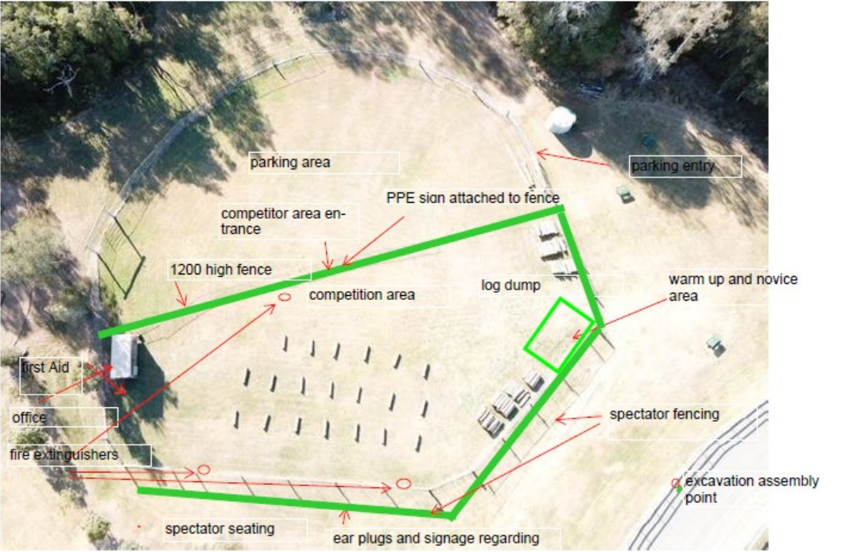
Sample Layout
- Spectator Area (2–3 metre buffer zone)
- Spectator Barrier/Fencing with Netting
– 1.2 metre high
- Competitor Safety Zone
- Chopping Block 1 to Block 2 –
2–3 metres apart
- Officials and Judges Office
- First Aid Station
- Fire Extinguishers
- Emergency Access Points
Additional Tips
- Signage: Clearly mark all areas, especially restricted zones and emergency exits.
- Inspection: Regularly inspect all barriers for damage; repair or replace as needed.
- Training: Ensure all competitors and officials are briefed on safety protocols and emergency procedures.
By following these guidelines, you can create a safe and efficient layout for your woodchop competition, ensuring the protection of everyone involved.

