
2018 ASC Next Generation Judging Workshop
Eugowra Showgrounds

About ASC Next Gen

The ASC of NSW Next Generation is delighted to be hosting the young judges workshop at Eugowra. For those of you who are unfamiliar with who we are and what we do, we are the youthful extension of the Agricultural Societies Council of NSW (ASC). The ASC is the advisory body for all the shows in country NSW and assist with things like insurance, policy making and future planning. As a result, the Next Gen’s role is to help with the youthful portion of the country show movement. That means we are your voice to get you involved in shows in the long term and provide the guidance and support you need to make the most of the country show family.
This booklet is aimed to give you a brief overview of all the classes we will be covering today, as well as room for you to make your own notes. The coaches we have provided are the best in their fields, they will give you many valuable points worth making note of!
If after today, you wish to learn more about ASC Next Gen, or you would like to get involved with our upcoming projects, do not hesitate to contact us at info@ascnextgen.com.au or find us on facebook, twitter and instagram.

Beef cattle

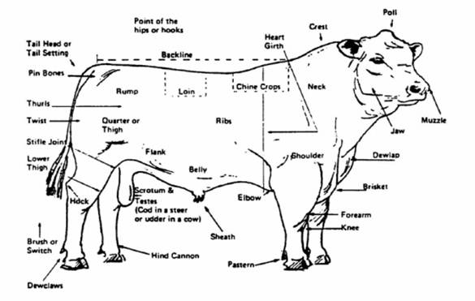

Top Tips:
- When judging beef cattle it is important to remember the purpose of these animals: they need to have a long productive life creating a high quality beef calves every year. Therefore the two most important traits to look for are structure and carcase.
- When judging cattle, always assess each animal in the same pattern. When the class starts, the animals will be paraded. This is a good opportunity to look for structural faults and lameness.
- After parading, animals will be lined up, this is a good opportunity to compare the size and shape of each animal, length, depth and muscle coverage are key traits to assess at this stage.
- When the animals are standing, it is ok to ask questions of the parader. You may touch the animal if deemed necessary, but always ask first. Visual assement should make up the majority of judging.
- Make note: when judging bulls, cows, heifers and steers, these animals all have slightly different purposes and therefore different judging criteria should be utilised. For example, a good teat placement is critical in a heifer, but useless in a steer!

Dairy cattle
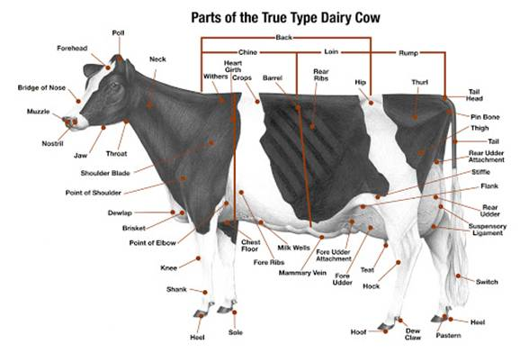

Top Tips:
- When judging dairy cows, it is important to remember their purpose: to have a long healthy life producing as much milk as possible. Therefore the key traits to assess are overall structure and udder development.
- The udder conformation of the cow should count for close to half of judging. Teats should be set square and the udder should be high and well attached. When judging heifers, it is difficult to assess the udder unless there are severe and obvious defects.
- Remaining factors focus on the longevity of the cow. She should have good “dairy strength”, which can be assessed by her depth and capacity. In addition she should have correct and sound legs and a wide rump where the hip bone sits slightly above the pins.

Fruit and vegetables

Top tips:
- In Fruit and Vegetable Judging we always assess three things regardless of the species we are judging. They are:
  - Evenness
  - Trueness to Type/Fitness for purpose
  - Freedom from defects
- Evenness means that each piece of fruit looks exactly the same. This could be the same colour, same shape, same size or same texture. We want all the pieces to look as identical as possible
- Trueness to type/Fitness for purpose means that the exhibit looks like it should. Eg are all the apples round, with a flat bottom, or do they have trouble standing up? Or are the oranges too green to eat? Are the potatoes a good size, or are they too small? If in doubt, think about what you would do with the produce (eat it fresh, chop it up, boil it etc) and which one looks the easiest or best to use.
- Freedom from defects means we want the produce to be as clean and healthy as possible, as damaged produce is a waste and must be thrown out. This could include rotten fruit, cuts from transport, cuts from harvest, insect damage and old fruit.
- When judging the produce, it is important to judge each exhibit in the same way. Start by lining all the fruit up in a row so you can assess the size. Get a good look from the side and the top. Then gently feel each exhibit for lumps, bumps, bruises and disease. Finally, smell the fruit quickly. It is important to handle the fruit gently, as you will be given points based on how well you handle the fruit when you judge it. Don’t drop the produce!

Grain

Top Tips:

- When we judge grain we are given a sample of grain and some details about it. The details include how heavy the grain is, and how much protein/oil the grain has. These details (given on a piece of card) are an important part of judging. More is a lot better! Except for barley, we want the protein to be between 9 – 12% because this barley goes into beer!
- When Judging grain, we always assess three core qualities:
  - Evenenss
  - Trueness to type/Fitness for purpose
  - Freedom from defects
- Evenness means that each grain should look the same. This is impossible to achieve, of course, but they should be as close as possible. This includes the size of the grains, the colour of the grains, the shape of the grains and their texture
- Trueness to type/fitness for purpose means that the grain looks like it should. This means that it has high protein/or oil, that it is the right colour and shape.
- Freedom from defects means that the sample is as healthy as possible. We want it to have no impurities like sticks, husks or other grains, the grains need to not have any diseases (like black tip) or growth defects (like mottling or pinched tips). Most importantly the grain MUST NOT HAVE WEEVILS. You can tell weevils are present because the grain will smell musty and there will be holes in the grain. Weevils are a huge problem because they destroy grain, then will move on to someone else’s grain. A sample with weevils in it is automatically placed 4th, no matter how good it is otherwise.
- When judging grain, it is important to judge each sample in the same way. First, take note of the weight and oil protein content of the sample. Then grab a small handful of the sample to look at a sample of the individual grains. Finally comb through the sample to look for defects.

Meat sheep
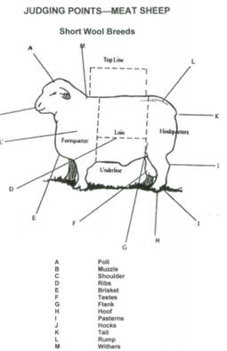
Top Tips:
- When judging meat sheep it is important to remember their purpose: To live a long life producing lambs that will have a high meat yield at slaughter. This means that the breeding stock must carry a good carcase as well as be sound and healthy.
- When judging sheep, always look at each animal in the same way. First, stand back and assess the class from a distance, taking in the size of each animal, their shape and the structure of their legs. We want legs to be straight and pasterns to be high.
- Then feel each individual animal. Open the mouth, the teeth must sit flat against the pad. Overshot/undershot jaws are a serious issue because the animal cannot eat properly. Check the eyes and ears to ensure they are clear. Some breeds can have black pigment (suffolks, white suffolks) others can’t (Poll Dorsets, Border Leisters).
- Then feel the shoulders. We want the shoulders to be smooth.
- Feel fat cover over the ribs, we want some coverage but not too much.
- Assess the size of the loin by gently feeling it with your hands. The loin is the most valuable cut of meat, so bigger is much better! Also take the time to feel the backbone over the loin, if it is prominent, the animal is underweight.
- Finally, feel the size of the twist, the second most valuable cut of meat resides here. Bigger is better!

Merino
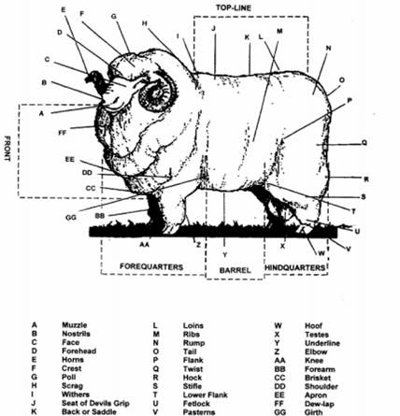
Top Tips:
- When judging a merino, the primary function must be kept in mind; which is an animal that produces excellent quality wool with a constitution that ensures a long lifespan.
- When judging a merino sheep, always approach the animal in the same way.
- Stand back to look at the class first, assessing the frame and structure of each animal. We want animals with sound, straight legs, high pasterns, and a deep body that will yield a high volume of wool.
- Inspect the teeth to ensure they are square against the pad. Overshot or undershot jaws are a concern as the animal will not be able to eat properly. Ensure there are no black spots on the face or ears.
- If judging rams, check the horns to ensure they are not too tight.
- Part the fleece in several spots, just beside the back, along the side and down the leg. We are looking for fleece that is uniform in length, character, brightness and density. Fleece should be free from disease (eg dermatitis, fleece rot), bright white, evenly crimped throughout and soft.

Wool
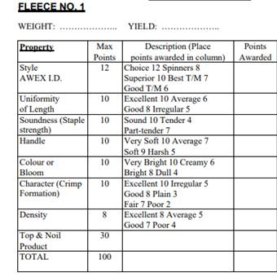
Top Tips:
- When judging fleece, it is important to remember the purpose of each individual fleece, which is to create as many top quality garments as possible.
- Fleeces are judged a little differently to most competitions, as each fleece is assigned as score card (as shown above). Do not let this scare you – it is a useful guide to ensuring you are checking all the right things! The best way to judge fleeces is to go through each fleece one at a time, checking it against the score cards provided.
- First and foremost, top and noil must be calculated through the use of a top and noil book (provided). Top and noil is best described as “how much yarn will this fleece give us once we clean and process it?” The more we get at the end, the higher the point score.
- Style is perhaps the most difficult attribute to define and refers to the overall quality of the wool.
- Uniformity of length refers to how much of the fleece is the same length. We want a fleece that is as even as possible
- Soundness defines whether the staples will tear under pressure. This happens when the sheep has had a stressful event in the last 12 months. Gently tap the individual staples to assess this
- Handle refers to softness. Grab the fleece in a few places to asses this. The softer, the higher the score.
- Character refers to how well the fleece crimps. Does the staple have the same amount of crimp the whole way down it? Is the crimp the same when you compare staples? The more uniform, the better.
- Lastly density refers to “how much wool is in a handful”. Grab a few handfuls of fleece in places to assess this.

Optimising the Oral Section
Top Tips:
- To do well in the oral section, it is important to know how it is scored. Of 50 points, 10 are allocated each for dress and speaking ability and 15 points are allocated each for accuracy of observation and comparison between exhibits.
- Appropriate dress consists of enclosed dress shoes, dress pants or skirt, belt, button up shirt and tie/scarf/pearl necklace. Blazers should be worn except when handling sheep and a hat may be worn outside. Attire should be clean and tidy. Makeup is acceptable if subtle.
- Speaking ability refers to how clearly your message reaches its audience. Take the time to gather your thoughts and speak clearly and concisely. Remember at large competitions there is a 2 min time limit.
- Accuracy of observation consists of two parts: 1. How detailed are your thoughts on the exhibits you judged? And 2. Are they right
- Ability to compare exhibits is by far the most difficult to master. This means you are comparing the exhibits instead of describing them. For example “the ram in first place had the best depth and length in the class” is much better than “the ram in first place was deep and long”. The best way to get the hang of this is to practice writing comparing terms when taking notes in the visual judging.
- All speeches regardless of whether they are cattle, pig, alpaca, sheep, produce, or goat all have a magic formula, which is as follows:
  - Say thankyou!!
    - To the show society hosting the event.
    - To your over judge. Name them if you can.
    - To any sponsors (if there are any).
    - To the exhibitors for providing the exhibits you judged today.
  - State the order that you placed the class (Ie, I placed this class of angus heifers in the order of 4,3,2,1).
  - Explain why the first placed exhibit is the best
  - Compare the first and second placed exhibits
  - Compare the second and third placed exhibits
  - Compare the third and fourth placed (n.b. we never say ‘last’) exhibits
  - Give a positive comment on the class as a whole
  - Finish by re-stating your order.

